Data Analytics Assignment-1

Bar Chart:

Pie chart:

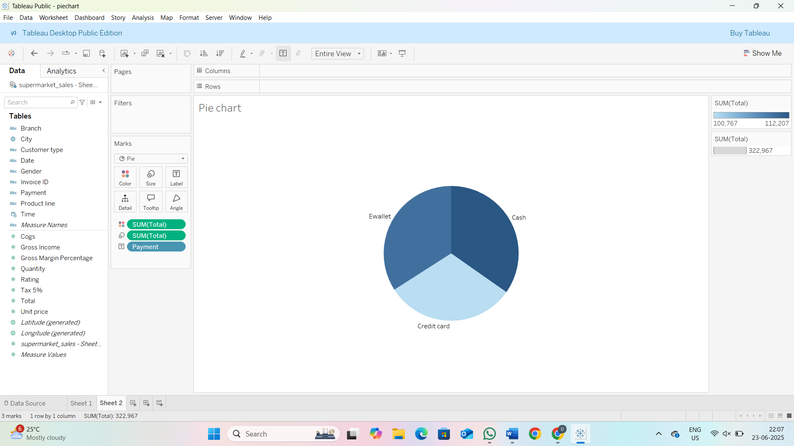

Stacked Bar Chart:

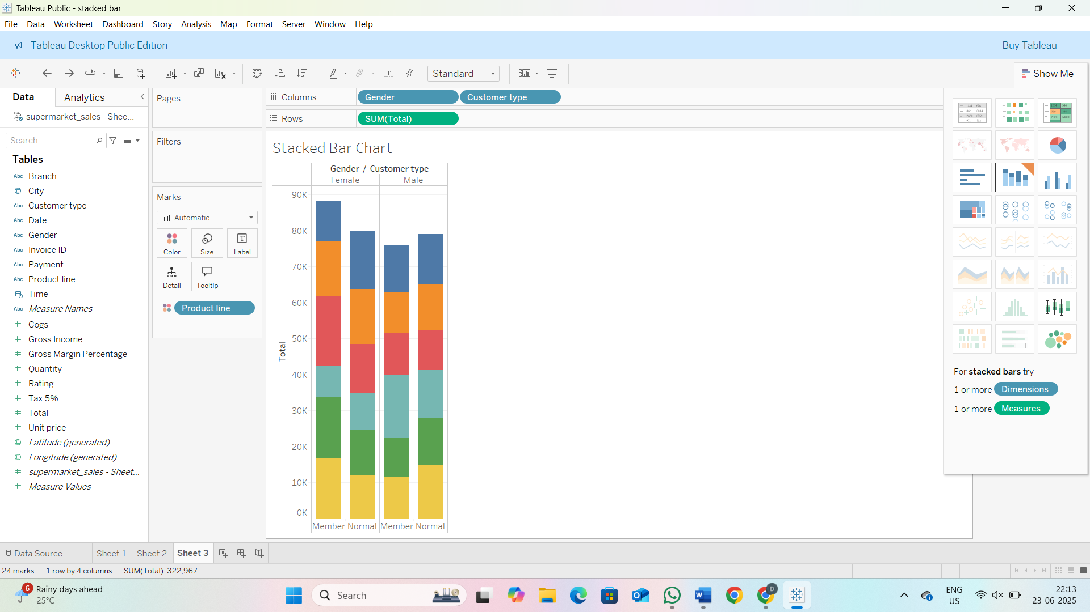

Line Chart:

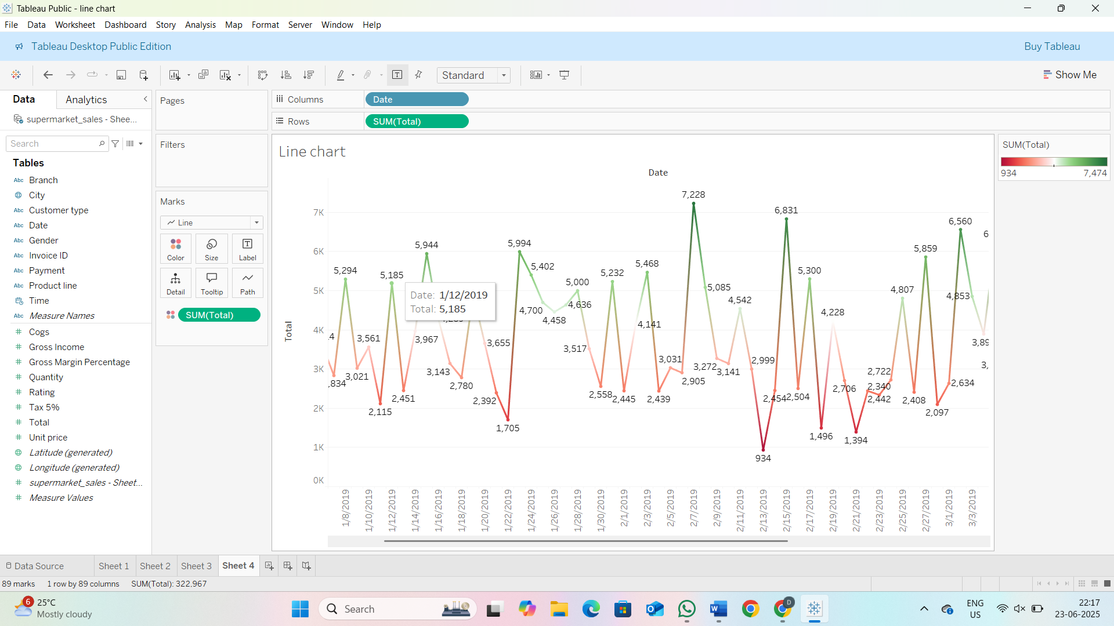

Bubble Chart:

